INSTRUCTIONS FOR MAIL MERGE FROM TEMPLATE

- Download the template (Word Doc) and the source file (Excel File). Save each to a prominent location. (For example, your Downloads folder.)

- Open the Word Doc template. Click “Mailings” in the ribbon.

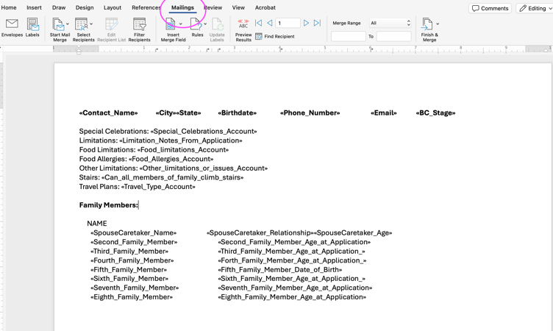

- Go to the “Start Mail Merge” option and click the down arrow.
- Select “Directory” for Volunteer list, “Letters” for Participants.

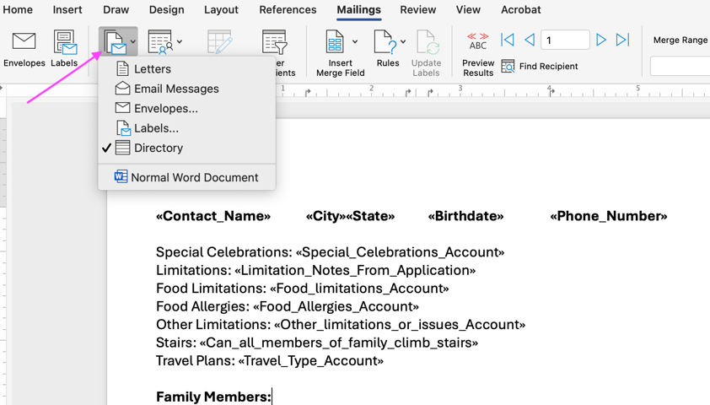

- Click “Select Recipients” and “Use an Existing List”.

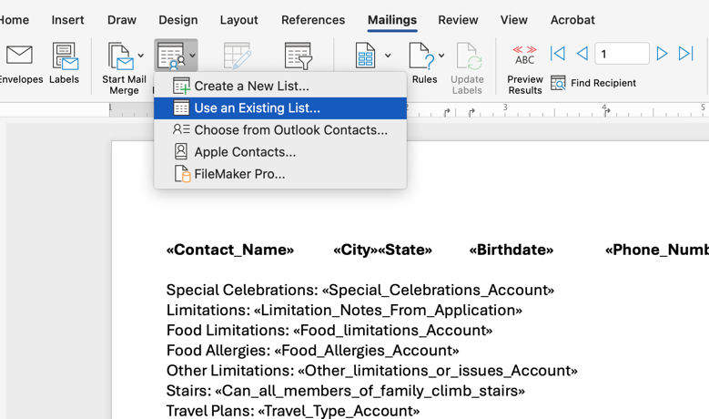

- This will show your folders. Select (highlight) the Excel file that you previously saved. Click “Open”.

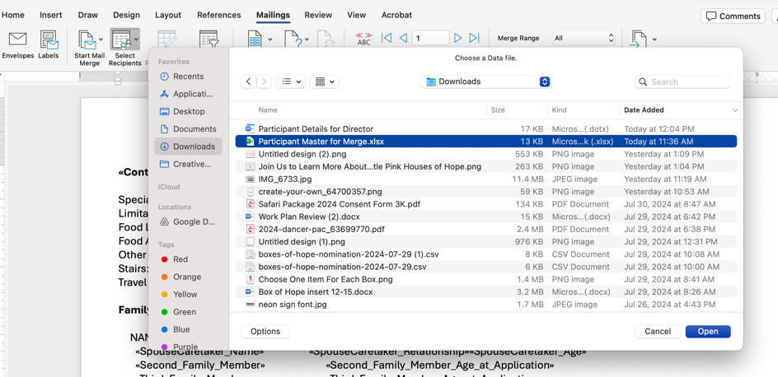

- You will see a warning about Excel and converting text. Click “Yes”.

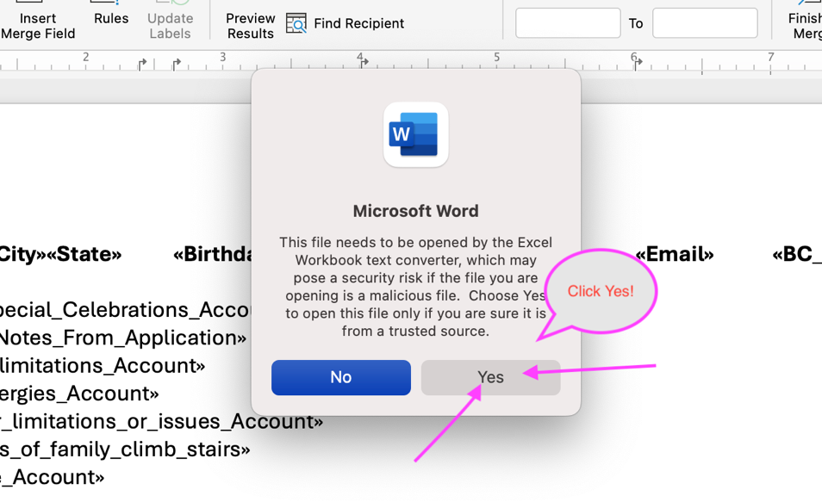

- Click “OK” to “Open Workbook” prompt. Do not enter anything in cell range.

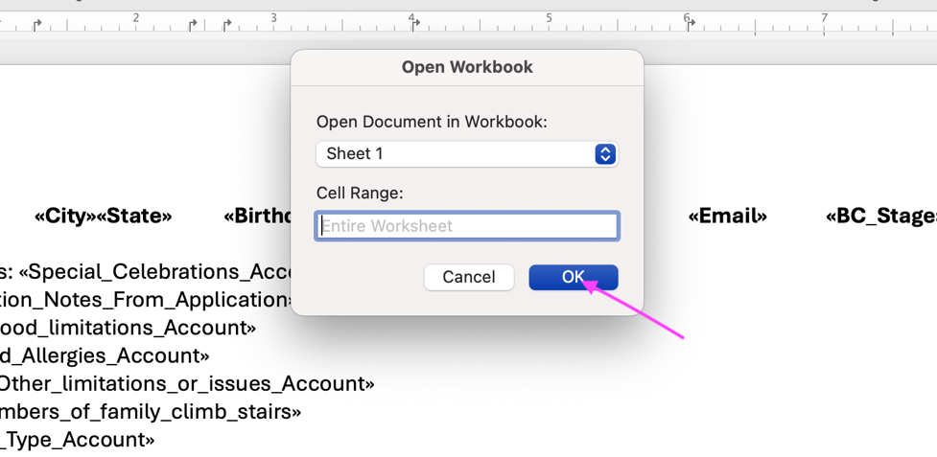

- Go to “Finish Merge” on the ribbon and click the dropdown arrow. Select “Edit Individual Documents”. This will create a brand new document, which is exactly what you want.

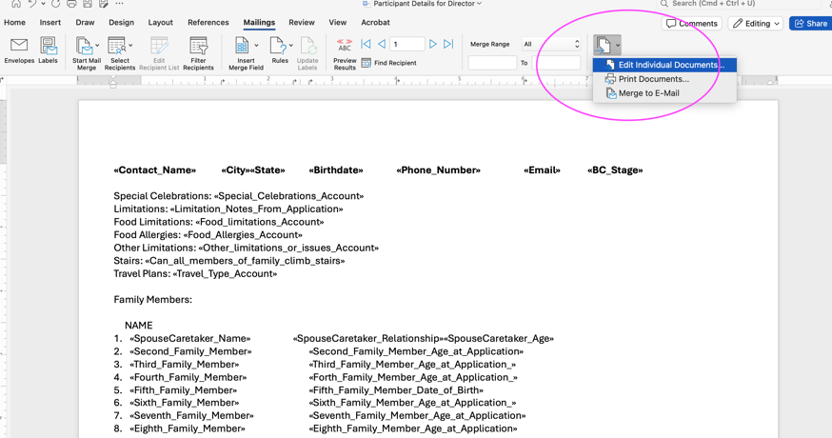

- All participant information should populate by each family, showing name, address, phone, email as the first line. Adjust spacing as needed after each family to get them all on their own pages.

- Save this new document under a different name, wherever you would like. Example: “Orange Beach Participant Info”.

- Print as needed. Use landscape layout.

