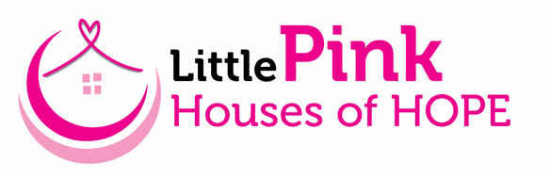

Little Pink Houses of Hope is non-profit organization that provides FREE weeklong vacations for breast cancer patients and their families. We believe a cancer diagnosis does not just affect the patient, but the entire family. We are excited about our upcoming retreat May 10-17, 2025, in Hatteras Island, NC, a community that has generously surrounded families with donations of meals, activities, and support for many years. Since 2010 over 2,000 families have experienced a week they will forever remember. The financial burden of every aspect of a vacation is removed so that families can relax, reconnect, and rejuvenate in a world free of appointments, doctors, and daily demands.

We are asking for your support! Our retreats leverage the compassion of generous donors to provide for our families in need. Our model is successful because of wonderful individuals, local businesses and organizations that provide houses, meals, activities, and financial support for our retreats. Little Pink Houses of Hope is a 501(c)3 organization and all financial donations and donations of goods and services are tax deductible.

Your generosity will help us continue to provide retreat opportunities for breast cancer families. Please feel free to contact me if you have any questions.

Thank you for giving families hope!
Sincerely,

Pam Rak
(559) 246-8267
pam@littlepink.org
Volunteer Retreat Coordinators, Hatteras Island, NC


www.littlepink.org

